Deploy Mr. Reese Chatbot

Facebook Messenger API <-> Broker (IBM Watson) <-> Mr. Reese

### We're going to set up a broker app that's tied to the Facebook API, and when someone sends a message on a Facebook fan page, it's ready to receive it and the broker processes the message and sends a request to Mr. Reese. Mr. Reese uses the **IBM Bluemix Conversation** to handle easy conversation questions that we hard-coded the answers. If no answers were found in IBM Bluemix Conversation, the bot will use **IBM Bluemix Discovery**to determine what information the user needs.

## 1.Preparation

Please install the following tools you need.

For linux/mac os x users, it is recommended to install them by the package manager of your linux system.

For windows users, you can link to following sites and install them by instruction.

1. git <https://git-scm.com/download/win>
2. python <https://www.python.org/ftp/python/3.6.0/python-3.6.0a3-amd64.exe>

please remember to add python to enviroment path while installing.

1. cloudfoundry-cli <https://github.com/cloudfoundry/cli/releases>

Also, you need to have a bluemix account, that's important.

## 2.Broker Setup

Please open your terminal/windows command line and type the following command.

git clone https://github.com/WeijianL1/COMP523-Mr-Reese

And then **change directory to** COMP523-Mr-Reese**.**

Edit the manifest.yml, change the name and host to whatever you like.

Notice that the name you choosed must be unique because the server would be work on the internet

applications:

- path: .

memory: 256M

instances: 1

domain: mybluemix.net

name: yourname-broker

host: yourname-broker

disk_quota: 1024M

## 3. Create Facebook fan page and application

If you don't have one, and then visit the facebook for developers website and create a app.

<https://developers.facebook.com/apps/>

[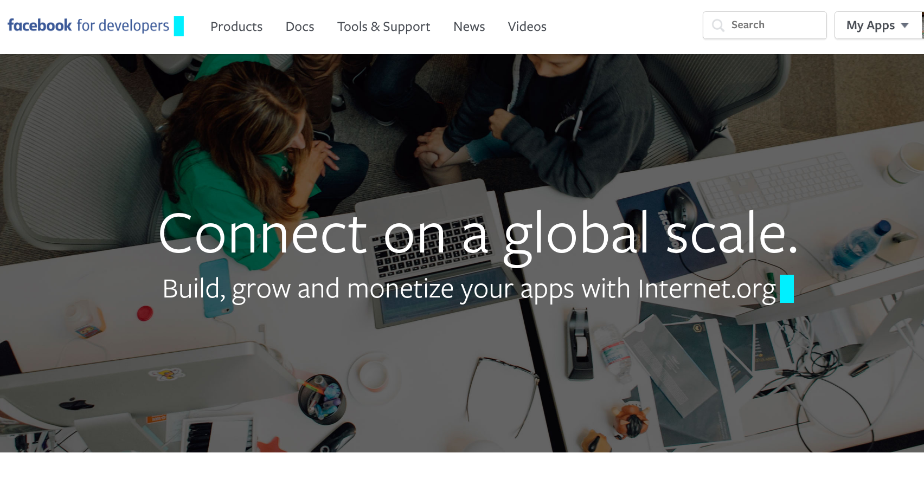](https://github.com/YuanYuYuan/Bluemix-tutorial/blob/master/facebook-weather-bot/pic/fb_developer.png)

Click 'Add Product' -> 'Messenger'.

[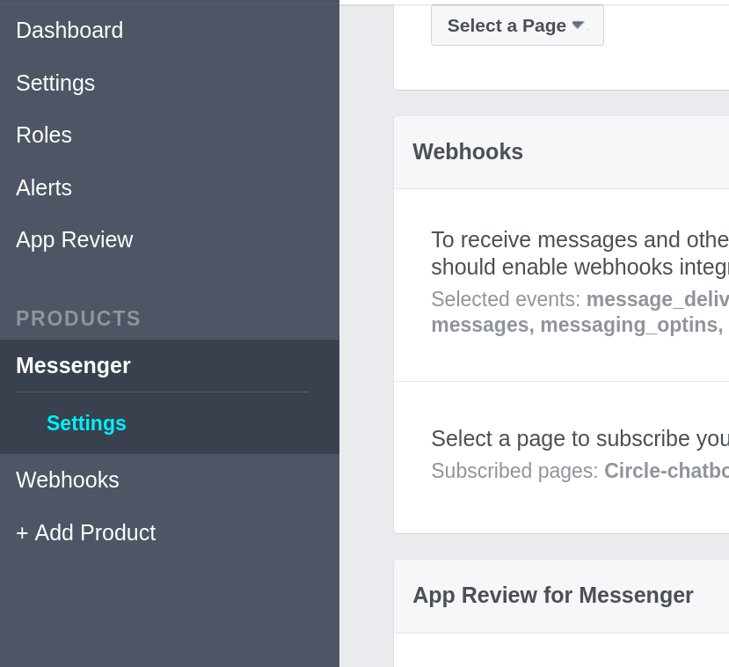](https://github.com/YuanYuYuan/Bluemix-tutorial/blob/master/facebook-weather-bot/pic/add_product.png)

## 4. Generate fan page Token

Choose your fanpage at Select a Page, and copy the page access token. Edit the .env and replace the FB_TOKEN token.

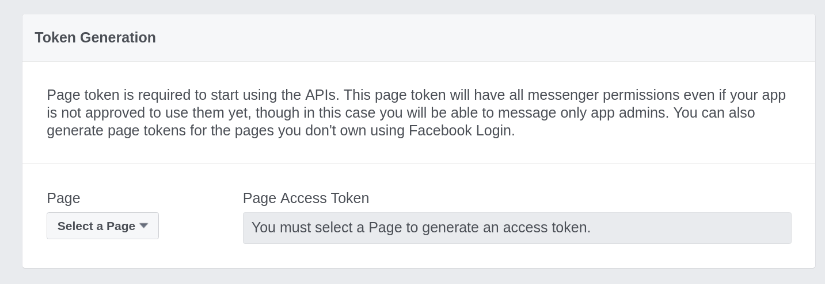  
Use cloudfoundry-cli to post this app

**cf login -a https://api.ng.bluemix.net**

**cf push**

If you are unable to log in via cf, make sure your organization and space are set correctly, making sure locale is set to US South. API point is set to https://api.ng.bluemix.net

If the Bluemix UI did not automatically guide you through the process of setting up your first sign in, create a new CloudFoundry under the Bluemix website and select any of the SDKs (which are not used), which automatically calls the Settings Wizard.

## Set Webhooks

Once the broker app is successfully executed in the cloud, go back to the Facebook developer page to set up the webhook.

[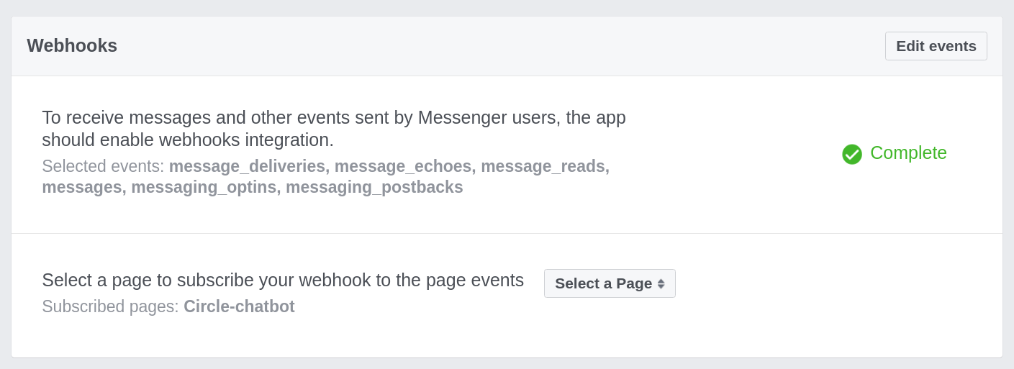](https://i1.wp.com/github.com/YuanYouYuan/Bluemix-tutorial/blob/master/facebook-weather-bot/pic/webhook.png?ssl=1)

* Callback URL: fill in the broker url (eg. [https://yourname-broker.mybluemix.net/webhook](https://yourname-broker.mybluemix.net/))
* Verification Token: Any non-empty string
* Subscription Field:
  + **message_deliveries**
  + **message_reads**
  + **messages**
  + **messaging_optins**
  + **message_postbacks** should be checked

[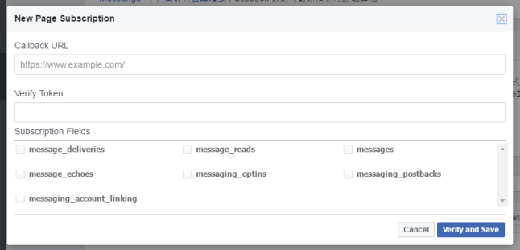](https://i2.wp.com/blog.cavedu.com/wp-content/uploads/2016/08/005.png)

Please go back to your fan page and hang the webhook and page events.

1. Use the system.  The final exam should begin with a system that is up and running and the instructions should allow the “client” to use all parts of it
2. Deploy the system.  The project owner is to take down the system and the client is to get it up and running again.  This includes any databases that are needed.
3. Change the system.  The project owner identifies a change that needs to be made to the system.  It is to be a trivial change such as a line of text change.  The client is to make the change to the source code and rebuild the system.  This change should be made in a test branch so that it can be easily reverted.  The project owner team can decide that there are several different tasks that they want the client to try.